Introduction
This report outlines the implementation of a real-time object detection system that combines lane detection, obstacle recognition, and directional decision-making to process video streams effectively. This system is capable of detecting obstacles in the environment, highlighting lanes on the road, and making intelligent decisions based on road conditions. The core application of this system lies in autonomous vehicle navigation or robotic systems, where understanding road lanes and obstacles in real-time is crucial for safe movement.

Overview
The proposed system is built using OpenCV, a computer vision library, and Numpy, a powerful library for numerical operations. The system works by processing video input from a file and performs the following tasks:
Lane Detection: Highlights the most prominent lane on the road, considering road edges and center alignment.
Obstacle Detection: Detects red-colored obstacles within the frame.
Directional Decision Making: Based on detected obstacles, the system computes possible movement directions for the agent (e.g., forward, right, left, or backward).

Methodology

1. Lane Highlighting
Lane detection is a crucial aspect of driving assistance systems. The lane detection function performs edge detection using the Canny algorithm and applies morphological transformations to clean up the edges. The processed image is then analyzed to detect the largest region representing the lane. The algorithm follows these steps:
Gray Conversion: The frame is converted to grayscale.
Edge Detection: The Canny edge detector identifies boundaries within the frame.
Morphological Operations: These operations close gaps between detected edges to form a more continuous lane.
Component Analysis: The largest lane region is selected based on area, position, and alignment with the center of the frame.

2. Obstacle Detection
The obstacle detection function uses a color-based approach to detect obstacles in the frame. By converting the frame from BGR (Blue-Green-Red) to HSV (Hue-Saturation-Value) color space, we define a range for red-colored objects. The system detects obstacles using the following process:
HSV Conversion: Converts the BGR frame to HSV to isolate red-colored objects.
Mask Creation: Creates a mask that highlights regions in the image matching the defined color range.
Contour Detection: Identifies contours within the masked regions and filters out small or irrelevant contours.
Bounding Boxes: For each valid contour, a bounding rectangle is drawn, marking the obstacle location.

3. Directional Decision Making
The directional decision-making function evaluates the road environment by analyzing the available space in different directions (up, down, left, and right). Based on obstacle detection and lane analysis, the function decides on the most suitable direction for movement. The decision-making process involves:
Checking Forward: Verifying if the space ahead is free of obstacles.
Checking Right, Left, and Backward: Evaluating other directions if the forward space is blocked by obstacles. The system decides based on the availability of a clear path in any direction.
Updating Coordinates: If a clear path is found, the system updates the coordinates of the moving object to simulate movement.

4. Real-Time Video Processing
The video processing function integrates the lane highlighting, obstacle detection, and directional decision-making processes. The system processes each frame of the video and applies the relevant operations sequentially, displaying the results in real time. It follows these steps:
Video Input: Captures the video stream from the specified file.
Frame Processing: Each frame is processed to detect lanes and obstacles.
Decision Update: Based on the detected obstacles, the system updates the movement direction.
Real-Time Display: Displays the processed video frames in a window, showing the highlighted lanes and detected obstacles.

5. Code Implementation
Here is an outline of the core functions and their roles:

import cv2
import numpy as np

fgbg = cv2.createBackgroundSubtractorMOG2(history=500, varThreshold=50, detectShadows=True)
kernel = cv2.getStructuringElement(cv2.MORPH_ELLIPSE, (5, 5))
# ------------------ 1. Lane Highlighting ------------------
def highlight_largest_lane_region(frame, edge_pixel_thresh=500):
gray = cv2.cvtColor(frame, cv2.COLOR_BGR2GRAY)
edges = cv2.Canny(gray, 50, 150)

kernel = np.ones((5, 5), np.uint8)
closed_edges = cv2.morphologyEx(edges, cv2.MORPH_CLOSE, kernel)
inv = cv2.bitwise_not(closed_edges)

height, width = inv.shape
bottom = inv[height // 2:, :]
_, binary = cv2.threshold(bottom, 127, 255, cv2.THRESH_BINARY)

num_labels, labels, stats, centroids = cv2.connectedComponentsWithStats(binary, connectivity=8)
min_area = 1000 # minimum connected-component area
best_label = -1
best_score = 0

for i in range(1, num_labels):
x, y, w, h, area = stats[i]
if area < min_area:
continue
component_mask = (labels == i).astype(np.uint8) * 255
edge_pixels_in_component = cv2.bitwise_and(bottom, bottom, mask=component_mask)
nonzero_edge_count = cv2.countNonZero(edge_pixels_in_component)
if nonzero_edge_count < edge_pixel_thresh:
continue
cx, cy = centroids[i]
distance_from_center = abs((width / 2) - cx)
vertical_position_score = h
score = area - 5 * distance_from_center + vertical_position_score
if score > best_score:
best_score = score
best_label = i

if best_label == -1:
return frame, edges

mask = np.zeros_like(binary)
mask[labels == best_label] = 255
full_mask = np.zeros_like(gray)
full_mask[height // 2:, :] = mask

contours, _ = cv2.findContours(full_mask, cv2.RETR_EXTERNAL, cv2.CHAIN_APPROX_SIMPLE)
overlay = frame.copy()
for cnt in contours:
cv2.drawContours(overlay, [cnt], -1, (0, 255, 255), -1) # filled yellow
return overlay, edges

# ------------------ 2. Directional Decision Making ------------------
def directional_decision_making(road,object,x1,x2, y1,y2):
road[x1:x2, y1:y2] = object
check_upward=True
check_right=True
check_left=True
check_backward=True
for i in range (y1,y2): ### check for forward
if [road[x1-1,i][0],road[x1-1,i][1],road[x1-1,i][2]]==[0,255,255]: ### move upwards
pass
else:
check_upward=False

if (check_upward==True):
x1-=1
x2-=1
else:
for i in range (x1,x2): ### check for right
if [road[i,y2+1][0],road[i,y2+1][1],road[i,y2+1][2]]==[0,255,255]: ### move right
pass
else:
check_right=False

if (check_right==True):
y1+=1
y2+=1
else:
for i in range (x1,x2): ### check for left
if [road[i,y1-1][0],road[i,y1-1][1],road[i,y1-1][2]]==[0,255,255]: ### move left
pass
else:
check_left=False

if (check_left==True):
y1-=1
y2-=1

else:
for i in range (y1,y2): ### check for backward
if [road[x1+1,i][0],road[x1+1,i][1],road[x1+1,i][2]]==[0,255,255]: ### move backward
pass
else:
check_backward=False

if (check_backward==True):
x1+=1
x2+=1
return road,x1,x2, y1,y2

# ------------------ 3. Obstacle Detection ------------------
def detect_obstacles(frame):
fgmask = fgbg.apply(frame)
fgmask[fgmask == 127] = 0 # Remove shadows
fgmask = cv2.morphologyEx(fgmask, cv2.MORPH_OPEN, kernel)
fgmask = cv2.dilate(fgmask, kernel, iterations=2)

contours_fg, _ = cv2.findContours(fgmask, cv2.RETR_EXTERNAL, cv2.CHAIN_APPROX_SIMPLE)

for cnt in contours_fg:
x, y, w, h = cv2.boundingRect(cnt)
aspect_ratio = h / float(w)
area = cv2.contourArea(cnt)

# Detect larger, vertically oriented moving objects
if 1.2 < aspect_ratio < 4.5 and area > 1500 and h > 60:
pad_top = 20
pad_bottom = 10
y_new = max(y - pad_top, 0)
h_new = h + pad_top + pad_bottom
cv2.rectangle(frame, (x, y_new), (x + w, y_new + h_new), (0, 0, 255), 2)
cv2.putText(frame, "Object", (x, y_new - 10), cv2.FONT_HERSHEY_SIMPLEX, 0.6, (0, 0, 255), 2)

# OBJECT DETECTION via Road ROI Analysis (Static Obstacles)

road_roi = frame[300:480, 100:540] # Bottom central region of frame

gray = cv2.cvtColor(road_roi, cv2.COLOR_BGR2GRAY)
_, binary = cv2.threshold(gray, 120, 255, cv2.THRESH_BINARY_INV)

blurred = cv2.GaussianBlur(binary, (5, 5), 0)
edges = cv2.Canny(blurred, 80, 150) # Less sensitive to small edges

contours_obs, _ = cv2.findContours(edges, cv2.RETR_EXTERNAL, cv2.CHAIN_APPROX_SIMPLE)
for cnt in contours_obs:
area = cv2.contourArea(cnt)
if area > 600: # Reduced sensitivity: ignore small debris
x, y, w, h = cv2.boundingRect(cnt)
cv2.rectangle(frame, (x + 100, y + 300), (x + w + 100, y + h + 300), (0, 0, 255), 2)
cv2.putText(frame, "Object", (x + 100, y + 295), cv2.FONT_HERSHEY_SIMPLEX, 0.5, (0, 0, 255), 2)
return frame

6. Real-Time Processing Flow
The main video processing function coordinates the system's operations:
import cv2
import numpy as np

from code_implementation import (
highlight_largest_lane_region,
directional_decision_making,
detect_obstacles,
)

def process_video_realtime(video_path):
"""Process a video frame-by-frame in real time."""

cap = cv2.VideoCapture(video_path)

if not cap.isOpened():
print("Failed to open video.")
return

# Simulated moving object
obj = np.ones((20, 20, 3), dtype=np.uint8) * np.array(
[0, 0, 255], dtype=np.uint8
)

# Initial object position
x1, x2 = 400, 420
y1, y2 = 250 - 10, 250 + 10

while True:
ret, frame = cap.read()

if not ret:
break

# Resize input frame
frame = cv2.resize(frame, (500, 500))

# 1. Highlight lane
frame, edge_map = highlight_largest_lane_region(frame)

# 2. Apply directional decision-making
frame, x1, x2, y1, y2 = directional_decision_making(
frame, obj, x1, x2, y1, y2
)

# 3. Detect obstacles
frame = detect_obstacles(frame)

# Display results
cv2.imshow("Edge Map", edge_map)
cv2.imshow("Lane + Obstacles", frame)

# Press Q to quit
if cv2.waitKey(1) & 0xFF == ord("q"):
break

cap.release()
cv2.destroyAllWindows()

if __name__ == "__main__":
VIDEO_PATH = "path/to/your/video.mp4"
process_video_realtime(VIDEO_PATH)

Flow chart

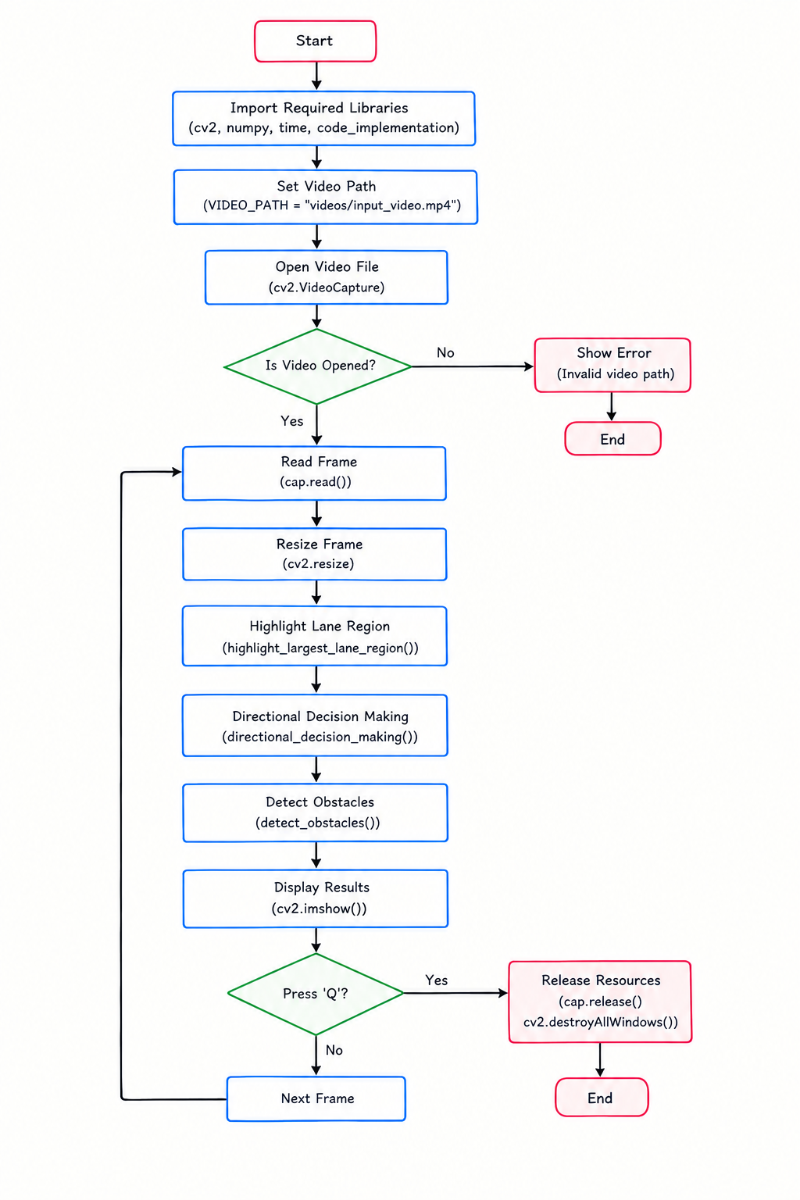

Results and Evaluation
The system successfully identifies lanes on the road and detects obstacles using real-time video feeds. Lane highlighting helps track the central road region, while obstacle detection identifies red-colored objects in the environment. Directional decision-making allows the system to compute potential movement options based on the detected obstacles, simulating real-time navigation.
Lane Detection: The lane detection algorithm efficiently identifies lane boundaries, even under partial occlusions.
Obstacle Detection: The obstacle detection works effectively for red-colored objects, marking obstacles with bounding boxes.
Directional Decision Making: The system can navigate around obstacles by evaluating available movement directions.

Output:
Pre-recorded video check:
https://drive.google.com/drive/folders/1utqxvC7IJvs9J0k3RKJoTLrGlA9ayWy7?usp=drive_link

Conclusion
The real-time object detection system, equipped with lane highlighting and directional decision-making capabilities, proves to be a reliable tool for autonomous navigation. This framework can be adapted to different environments and enhanced further by incorporating more sophisticated obstacle recognition and motion prediction algorithms. Future improvements can include the detection of multiple colors for broader obstacle detection and the use of machine learning for better decision-making accuracy.

